**1. Introduction**

**PTU CSE SYLLABUS GUIDE** is a project dealing with the ptu cse students problems of finding the good & quality resources for their study. So this project could be one and only to deal with it. The ptu cse syllabus guide will include the notes, books, question banks, previous years question papers, and quiz. Thus the students need not have to look any further for studying their current subjects and hopefully this will decrease the burden on the students of finding the different topics from the internet. Thus this project could prove to a game changer for ptu cse students, whether they are doing the thorough study of the subject or just walking through the subject during sessional or examination. The project is open source & is under the Apache License, Version 2.0. It could prove to be the time effective solution for the students. This project will work on all major platforms including windows, android, ios, windows phone, blackberry, Ubuntu OS, Firefox OS etc.

**1.1) Purpose**

The purpose of this project is to provide a single fully functional environment that contains notes, syllabus, question banks, previous years question papers and quiz that will definitely helps students of computer science & engineering.

**1.2) Scope**

The scope of this project is widespread. It can run on any system with any browser i.e installed on your system. The database of this project is online, with a feature of user registration(login id) that is a user can share their own notes also with another students.

**1.3) Definitions**

The **PTU CSE SYLLABUS GUIDE** will includes student registration/login page, student page. In Student Registration students can fill their information to get the homepage. The homepage which is the user panel will include links to different semester pages. The different semester pages will have the further subject pages and the subject pages will have the notes, question banks, quiz, previous year question paper for different subjects. In starting of the project student fills his login information and if he is not registered he has to before using this guide. When the new user registers the admin of DB have right to give the privileges to the user. So after the admin gives rights to the user, then the user will be able to login with the information he has provided during the registration. After login the user will be taken to his profile page, where he can traverse to any subject by clicking the links or can just search for the subject or the topic and the results will be displayed instantly without refreshing.

**1.4) Overview**

As the **PTU CSE SYLLABUS GUIDE** is able to have user interface. It has User Registration form, Different Semesters Fields i.e From 3rd Semster to 8th Semester of Computer Science and Engineering Subjets and if we want to add new notes or any file then we can easily do it with the feature of file upload in User ID Section. So it is complete GUI Enviornment and very user friendly and made according to the students's requirements. Which will be understandable by the user with pencil and pen.

**2. Technology to be Used**

The front end used in this project is the HTML, CSS, jQuery, PHP and the backend is designed with the help of MYSQL 5.0.

**2.1 HTML:-** HTML stands for hypertext markup language.

* A markup language is a set of markup tags
* The tags describe document content
* HTML documents contain HTML tags and plain text
* HTML documents are also called web pages

**2.2 CSS:-** CSS stands for Cascading Style Sheets.

* Styles define how to display HTML elements
* Styles were added to HTML 4.0 to solve a problem
* External Style Sheets can save a lot of work
* External Style Sheets are stored in CSS files

**2.3 jQuery:-** jQuery is a lightweight, "write less, do more", JavaScript library. Features are

* HTML/DOM manipulation
* CSS manipulation
* HTML event methods
* Effects and animations
* AJAX

**2.4 PHP:-** PHP is server scripting language, and is a powerful tool for making dynamic and interactive Web pages quickly. PHP is widely used, free and efficient alternative to competitors such as Microsoft’s ASP.

* PHP is an acronym for hypertext preprocessor
* PHP is widely used, open source scripting language
* PHP script are executed on the server
* PHP cost nothing, it is free to download and use.

**2.5 MySQL**- MySQL Queries can be used retrieve large amount of records from a database quickly and efficiently. Using standard SQL it is easy to manage database system without having to write substantial amount of code. It is portable used for relational databases easy to learn and understand interactive language dynamic database.

**3. OVERALL DESCRIPTION**

**3.1) Product Perspective**

As the **PTU CSE SYLLABUS GUIDE** is able to have user interface. It has User Registration form, Different Semesters Fields i.e From 3rd Semster to 8th Semester of Computer Science and Engineering Subjets and if we want to add new notes or any file then we can easily do it with the feature of file upload in User ID Section. PTU CSE SYLLABUS GUIDE is compatible with operating systems like Windows Xp , Windows7 , Ubuntu.

**3.2) Product Functions**

The following are the product functions of the **PTU CSE SYLLABUS GUIDE**:

**PTU CSE SYLLABUS GUIDE** works in different modules-

* **Semesters:** 3rd to 7th Semester having syllabus, Sample Papers and Notes of all the subjects.
* **Quiz:** Quiz of all the semesters.
* **File Upload:** Each user can share their own notes with the help of file upload feature.
* **User Profile:** Here user can create his own personal profile.

**3.3) User Characteristics**

* Online Notes and Syllabus.
* Fully functional environmet with different module built in .
* Ability to create user profile to share their own notes.
* Sample Papers of all the semesters.
* User Friendly GUI interface.

**3.4) Compatibility**

Compatibility of PTU CSE SYLLABUS GUIDE is with all the Operating Systerm, It is a web app with a responsive design compatibility with Browsers like Chrome, Firefox, Safari etc and also with the mobile Browsers.

**4. SPECIFIC REQUIREMENTS**

**4.1) External Interface Required**

**4.1.1 User Interfaces**

PTU CSE SYLLABUS GUIDE provides Graphical User Interface. The users who can run this web app are those who have access to this webapp and their systems meet the minimum requirements to install/run this software package.

**4.1.2 Hardware Interfaces**

The external hardware interface used for accessing the PTU CSE SYLLABUS GUIDE is the personal computers of the end users. The PCs may be laptops with wireless LAN as the internet connections provided can be wireless or wired.

* + 1. **Software Interfaces**

The Operating Systems can be any version of Windows, Linux, Unix or Mac with Browser like Chrome, Firefox, Safari etc.

**4.2 Supplementary Requirements**

**4.2.1 Software Details:-**

|  |  |
| --- | --- |
| Front End | Apache server2.2, PHP 5.4.3 |
| Back End | MySQL |
| Server | XAMPP |
| Operating  System | Windows XP/ Windows Vista/  Windows 7/Ubuntu/MAC |

Table:1: Software Details

**4.2.2 Hardware Details**

|  |  |
| --- | --- |
| Processor | Intel Pentium 4 or Above |
| Space | 250MB (Recommended) |
| RAM | 512 MB(min.) |

Table :2: Hardware Requirements

1. **Feasibility Study of the Project**

At this stage the client’s or the user’s needs are analyzed, information about the project is gathered and the requirements of the system are collected and analyzed. The user’s expectation for the system implementation is studied and the proposed solution is offered.

**a) Technical Feasibility: -** If we talk about the technical feasibility of this project then it requires the resources and the technology to be available. This project requires PHP and MySQL software for the frontend and backend respectively which are very easily available. Moreover the requirements of the hardware are also low.

**b) Economic Feasibility:-** As per the cost considerations, this project requires a low cost to build up including the hardware and the software cost. The cost of implementation is also fair enough to implement this application.

**c) Operational Feasibility: -** As the project is made keeping in mind the various requirements of the user, it is nearly sure that it must be used by the user if developed and implemented and will not give any large problems on the site of implementation.

1. **Need and Significance of the project**

* This project is going to help the students by providing them all the resources needed for study from single source.
* This project will help the students during the exams when scanning to the subject is required.
* This project will also help the teachers.
* This project thus is not the benefit of one member, it is the benefit of the community.
* The students can take the quizzes time by time to boost up their memory pertaining to subject.

1. **Design**

**7.1) FULL WIDTH LAYOUT**

* Fixed-width layouts are much easier to use and easier to customize in terms of design.
* Widths are the same for every browser, so there is less hassle with images, forms, video and other content that are fixed-width.
* There is no need for min-width or max-width, which isn’t supported by every browser anyway.
* Even if a website is designed to be compatible with the smallest screen resolution, 1356×768, the content will still be wide enough at a larger resolution to be easily legible.

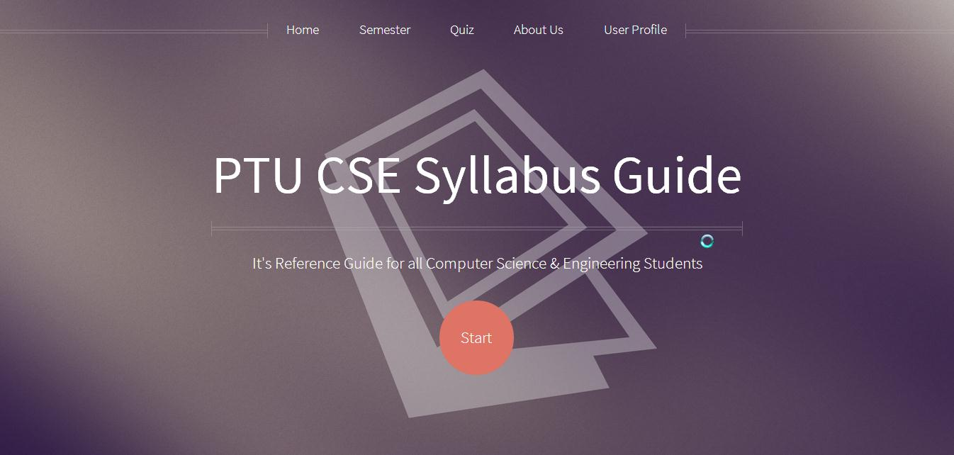

Figure 1 – Full Width Design of PTU CSE Syllabus Guide

7.2) **Responsive Design**

**Responsive Web design** (**RWD**) is a Web design  approach aimed at crafting sites to provide an optimal viewing experience—easy reading and navigation with a minimum of resizing, panning, and scrolling—across a wide range of devices (from mobile phones to desktop computer monitors)

* The fluid grid concept calls for page element sizing to be in relative units like percentages, rather than absolute units like pixels.
* Flexible images are also sized in relative units, so as to prevent them from displaying outside their containing elements
* Media Queries allow the page to use different CSS style rules based on characteristics of the device the site is being displayed on, most commonly the width of the browser.
* Server Side components (RESS) in conjunction with client-side ones such as media queries can produce faster-loading sites for access over cellular networks and also deliver richer functionality/usability avoiding some of the pitfalls of device-side-only solutions.

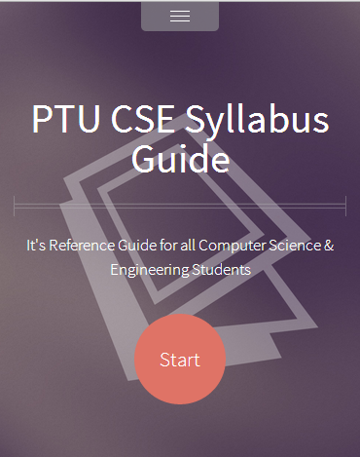

Figure 2- Responsive Design of PTU CSE Syllabus Guide

1. **Methodology/ Planning of Work**

The project will be follow the bottom up approach. First the smaller modules like login/registration page, semester pages, subject pages, contact us, about us etc. will be created and then they all will be combined for the completion of the project. In starting of the project student fills his login information and if he is not registered he has to before using this guide. When the new user registers the admin of DB have right to give the privileges to the user. So after the admin gives rights to the user, then the user will be able to login with the information he has provided during the registration. After login the user will be taken to his profile page, where he can traverse to any subject by clicking the links or can just search for the subject or the topic and the results will be displayed instantly in the current working windows.

**8.1) Flow diagram of PTU CSE SYLLABUS GUIDE**

PTU CSE Syllabus Guide

Semesters

Quiz

User Profile

Home

1st

2nd

8th

7th

6th

5th

4th

3rd

Sub n

Sub n

Sub 2

Sub 1

Sample Paper

Syllabus

Notes

Figure 3 – Modular Structure

Note

Sub- Subject.

Sample Paper – Previous Year Question Papers

Notes- Notes pertaining to subject.

Quiz – Quiz pertaining to different subject.

8.2)Use Case Diagram

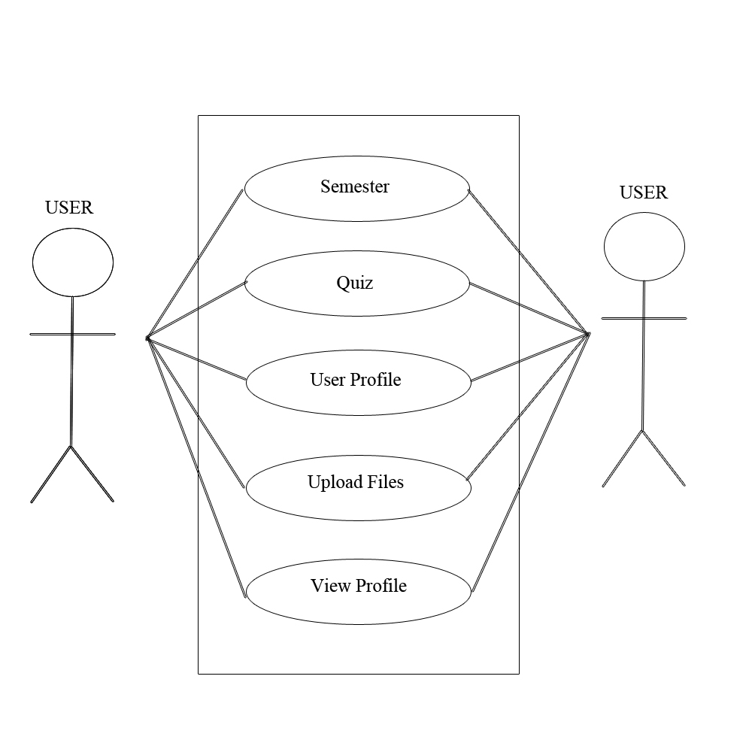

Figure 4 – Use Case Diagram

8.3)DFD

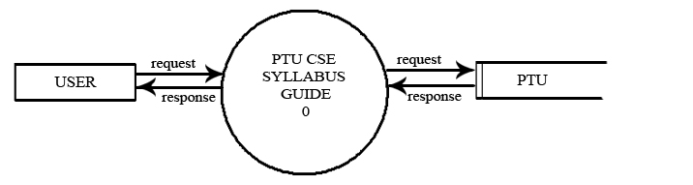

Figure 5 - DFD Level 0

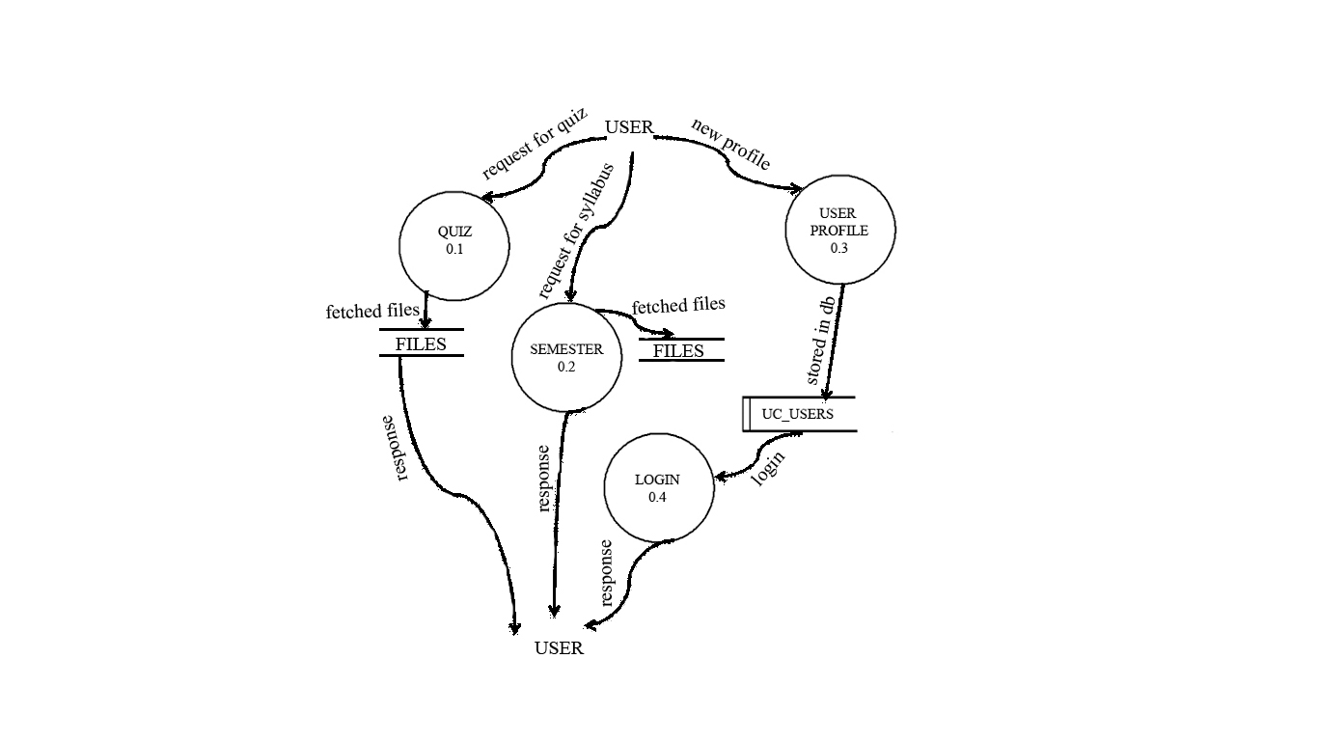

Figure 6 - DFD Level 1

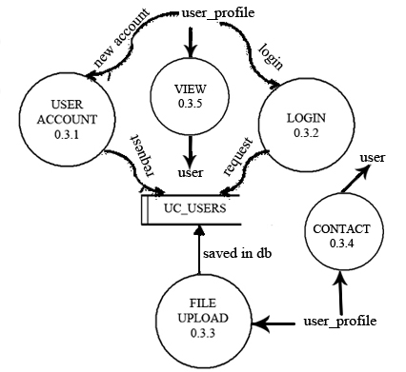

Figure 7 - DFD Level 2

**9.Snapshot**

**9.1)Index Page**



Figure 8 - Home Page

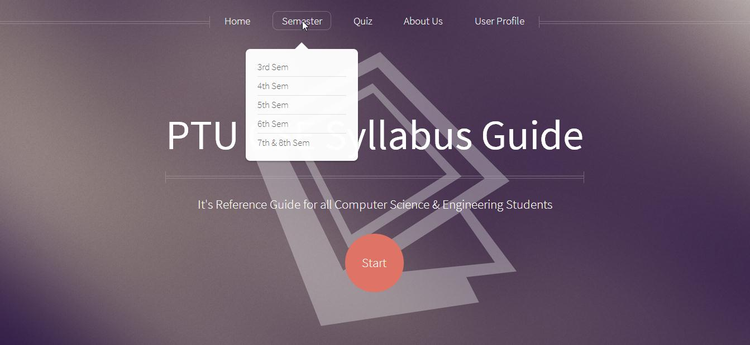

Figure 9 - Home Page Containing List of all the Semesters

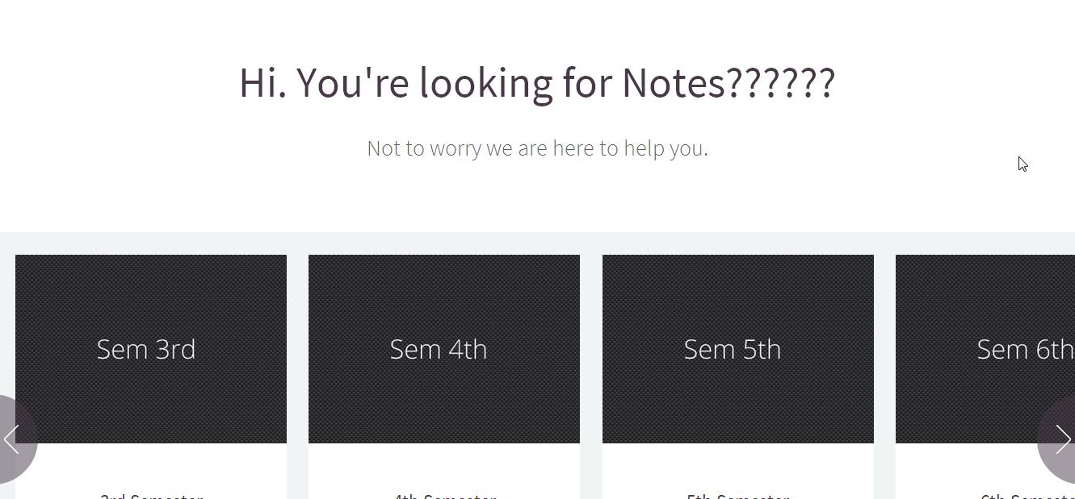

Figure 10 - Different Semesters Detail

**9.2) Semester Detail**

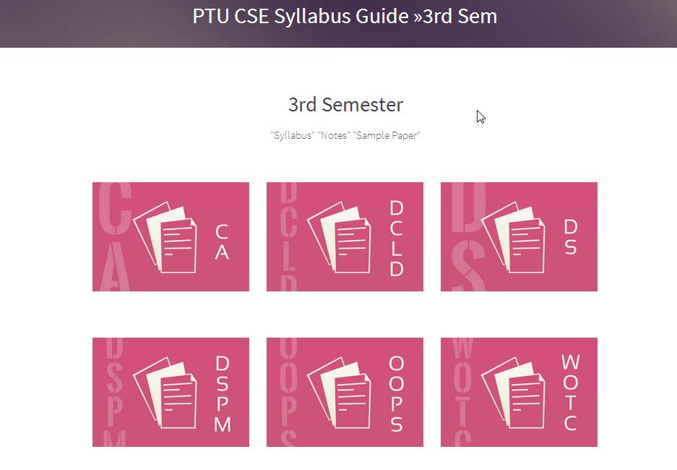

Figure 11- List of 3rd Sem. Subjects

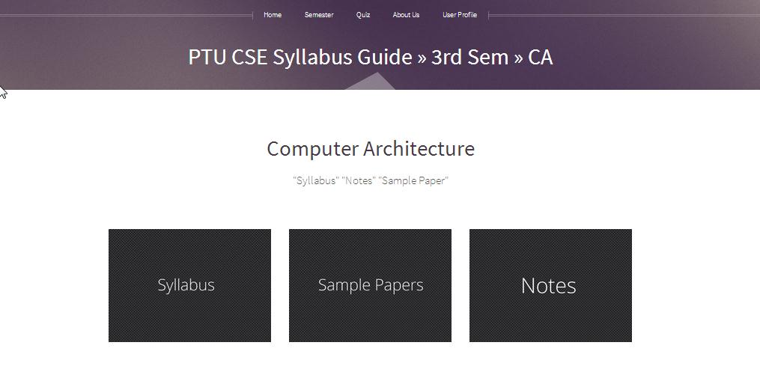

Figure 12 - 3rd Sem. Syllabus, Sample Papers, Notes Tabs

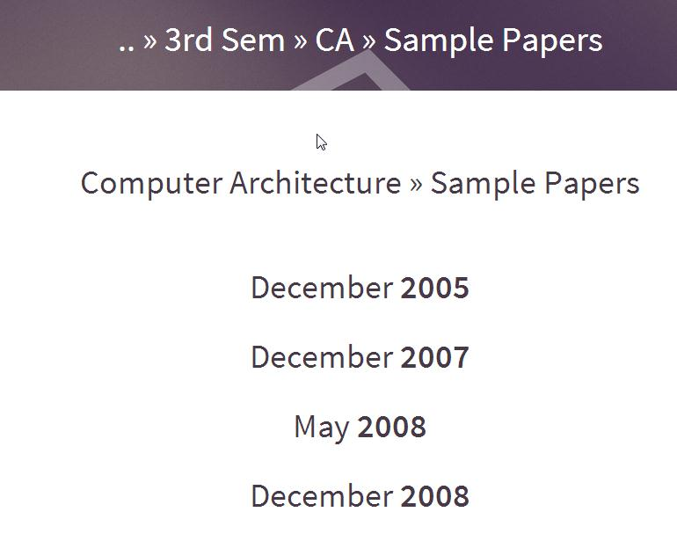

Figure 13 - Semester 3rd CA(Computer Architecture Sample Papers)

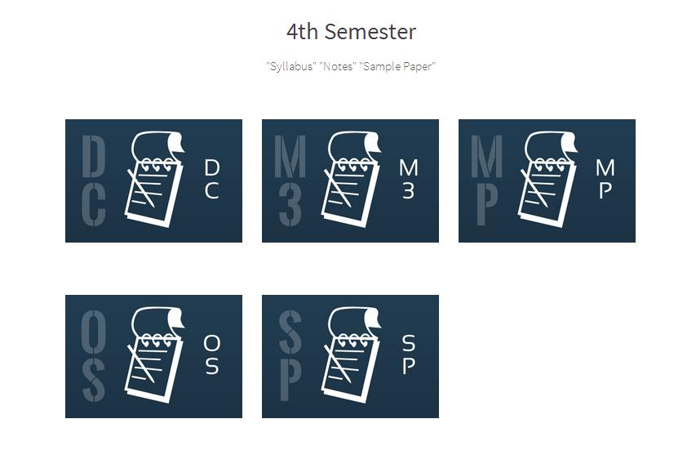

Figure 14 - List of 4th Sem. Subjects

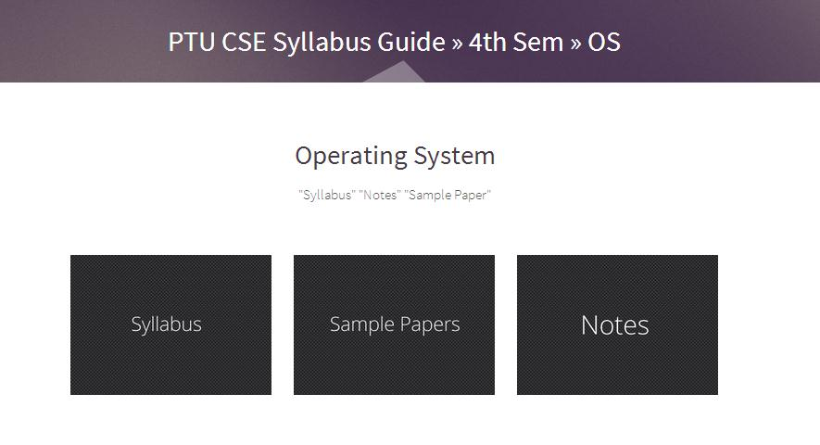

Figure - 15 4th Sem. Syllabus, Sample Papers, Notes Tabs

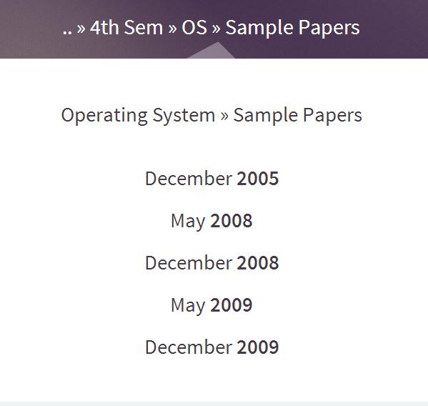

Figure - 16 4th Sem. Sample Papers

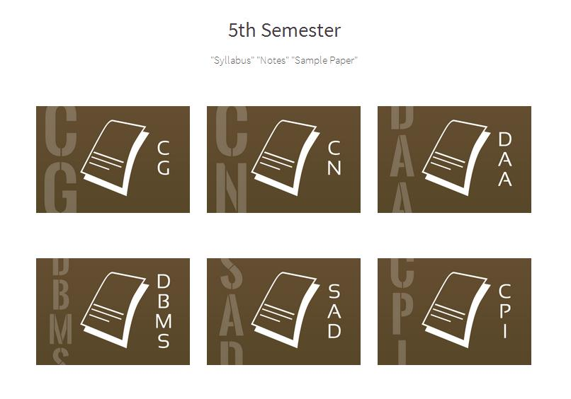

Figure - 17 List of 5th Sem. Subjects

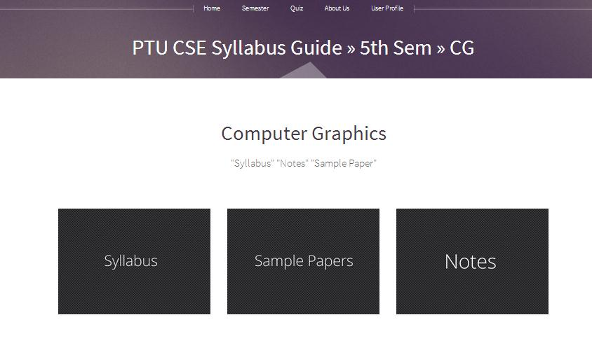

Figure 18 - 5th Sem. Syllabus, Sample Papers, Notes Tabs

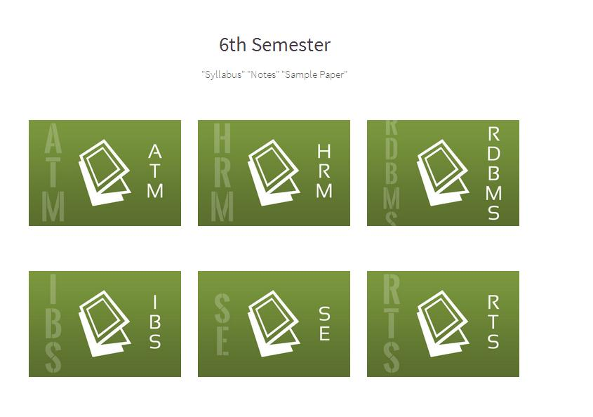

Figure 19 - List of 6th Sem. Subjects

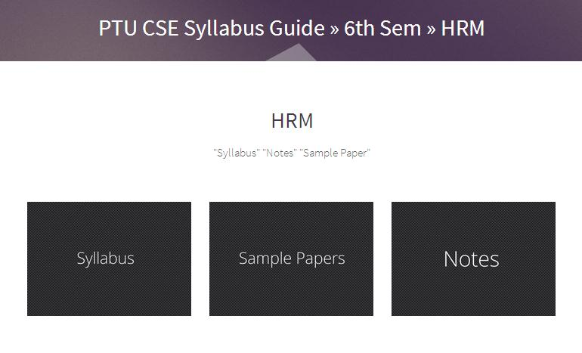

Figure 20 - 6th Sem. Syllabus, Sample Papers, Notes Tabs

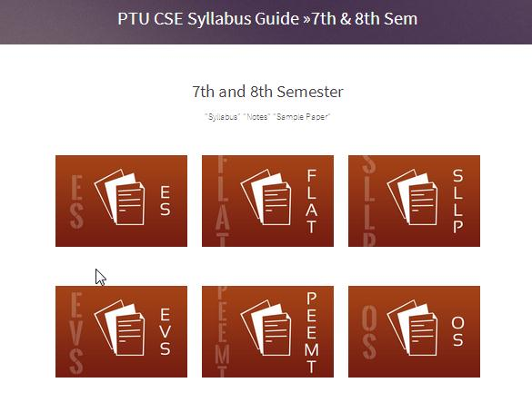

Figure 21 - List of 7th and 8th Sem. Subjects

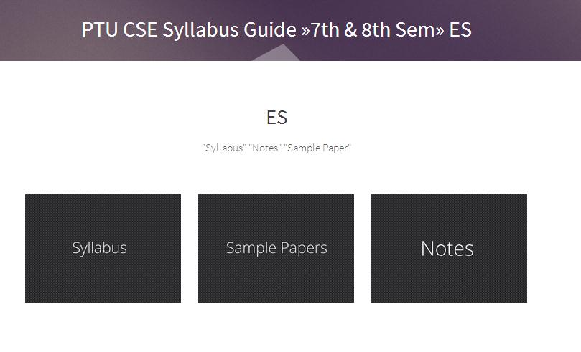

Figure 22 - 7th and 8th Sem. Syllabus, Sample Papers, Notes Tabs

**9.3) Quiz**

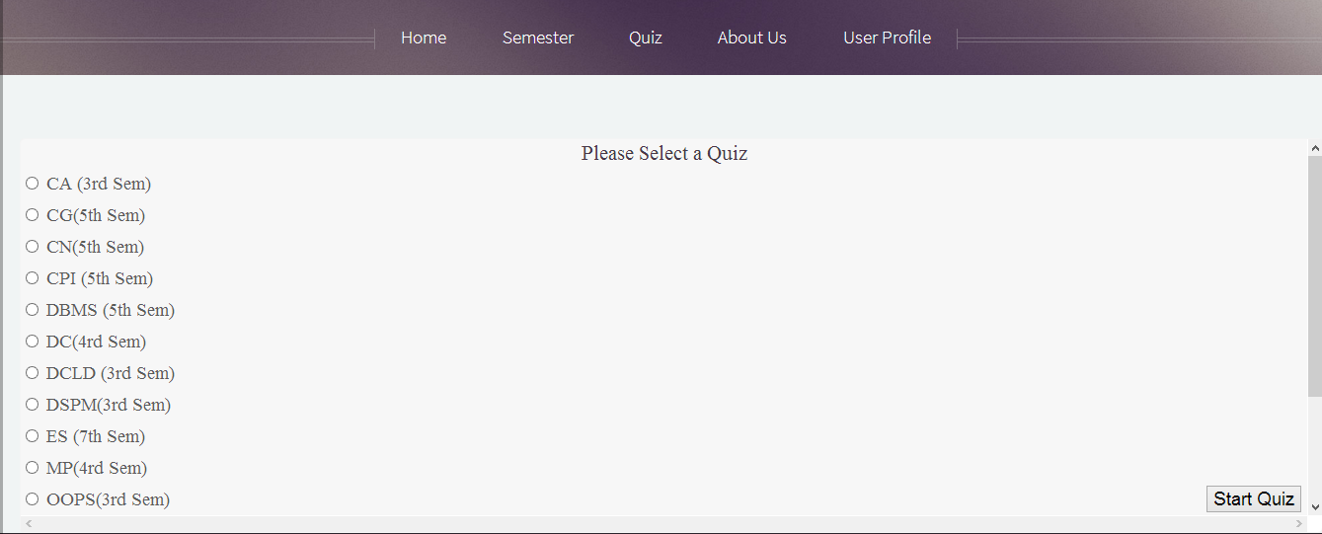

Figure 23 - Select a Quiz

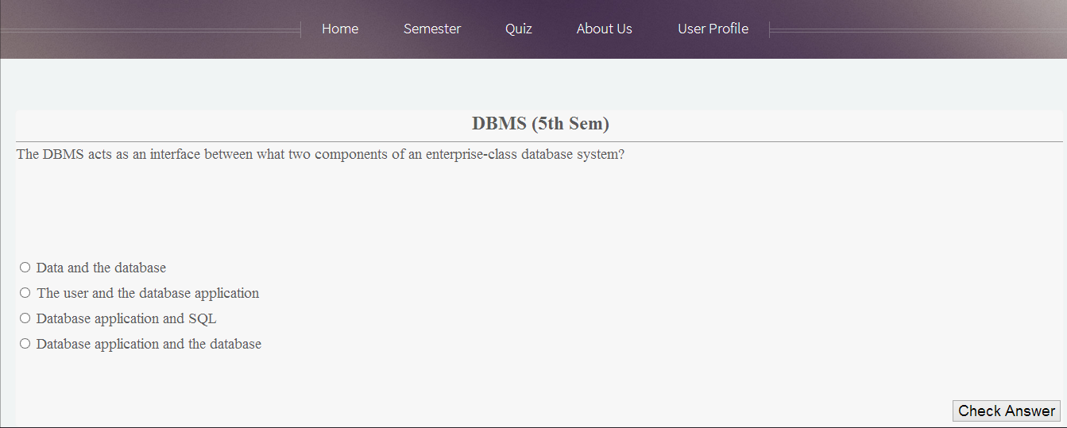

Figure 24 - Dbms Quiz

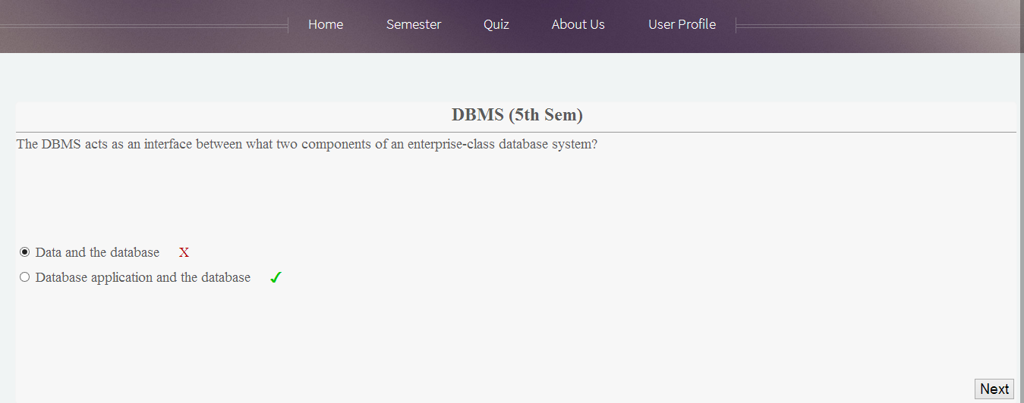

Figure 25 - Dbms Quiz showing right or wrong answer

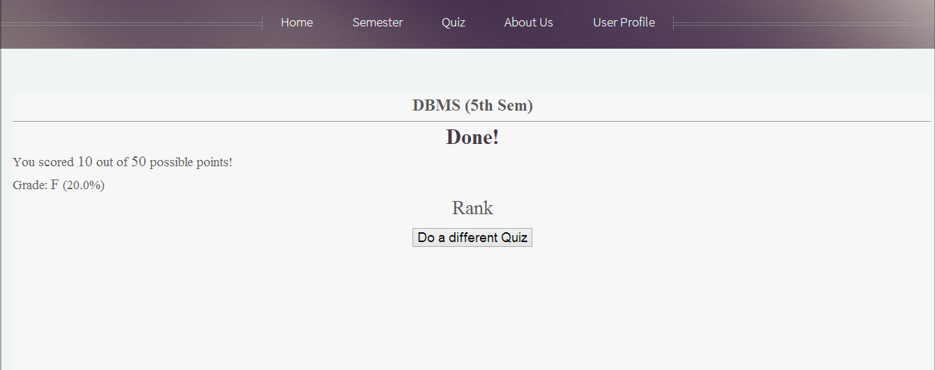

Figure 26 - Dbms Quiz Marks Detail

**9.4) User Registration and Login Detail**

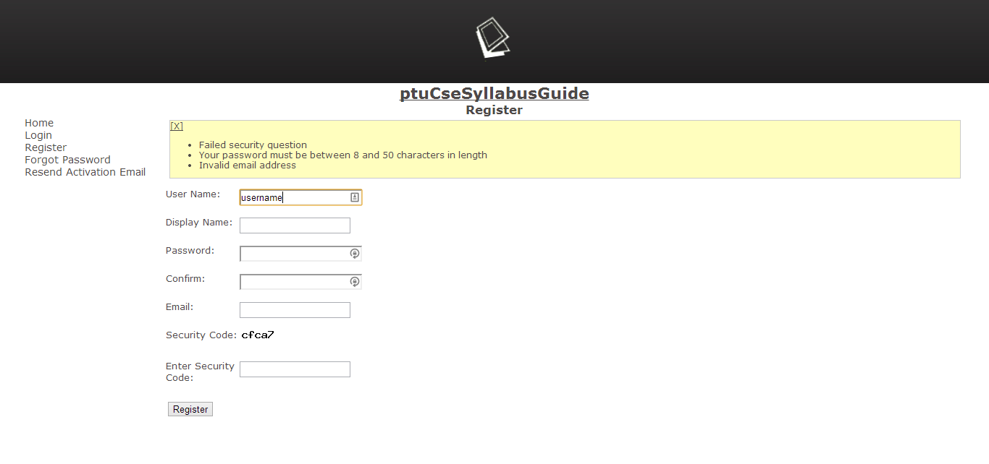

Figure 27 - User Registration

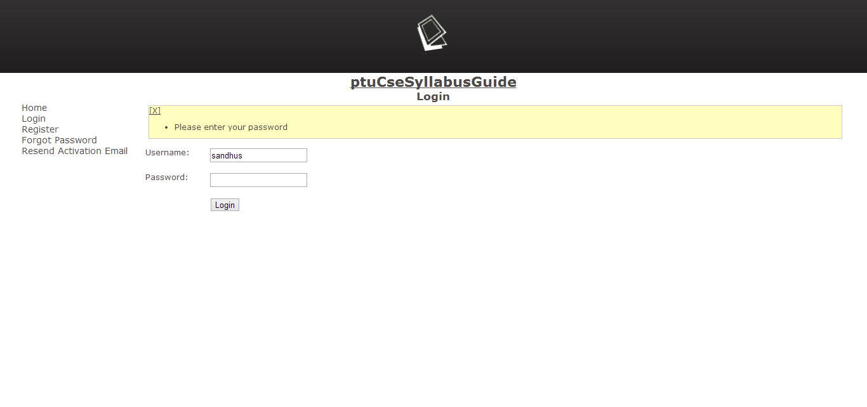

Figure 28 - User Login

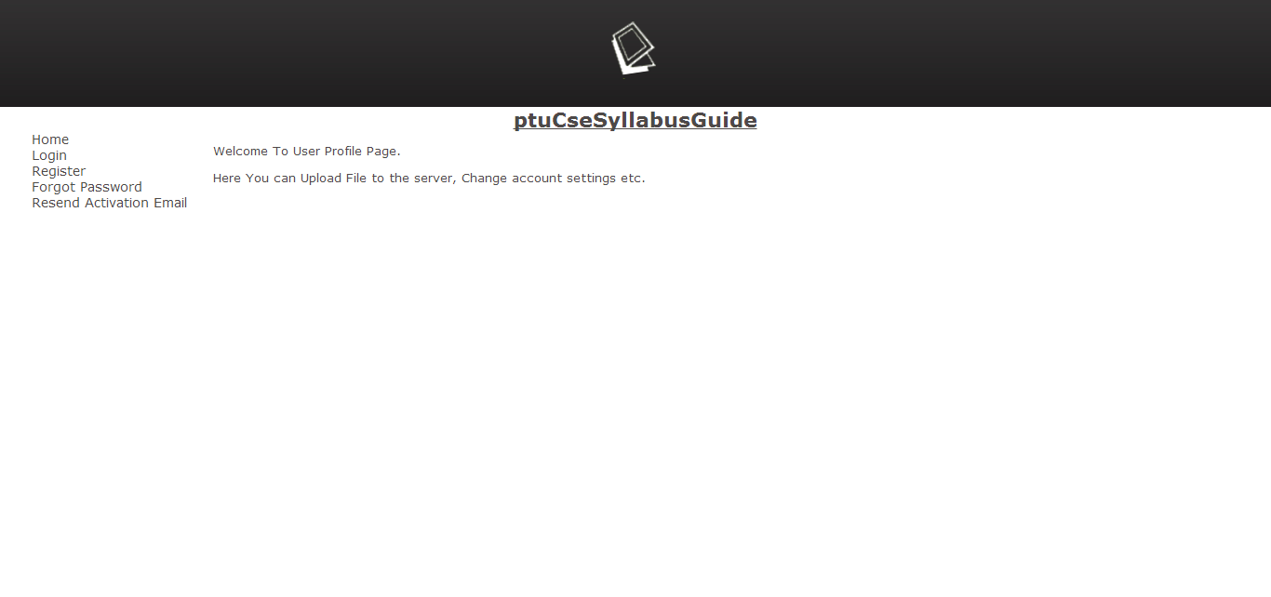

Figure 29 - User Area after login

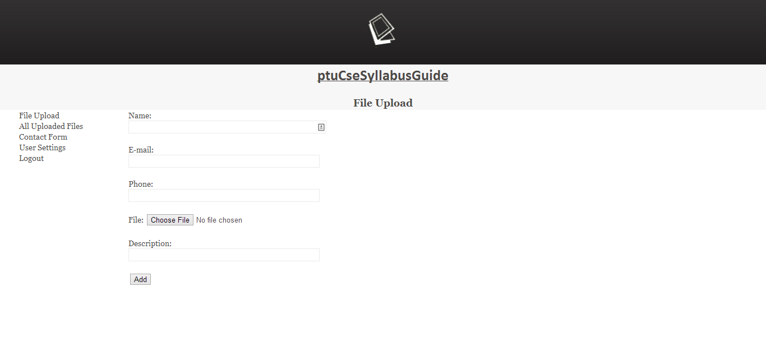

Figure 30 - File upload option in User Area

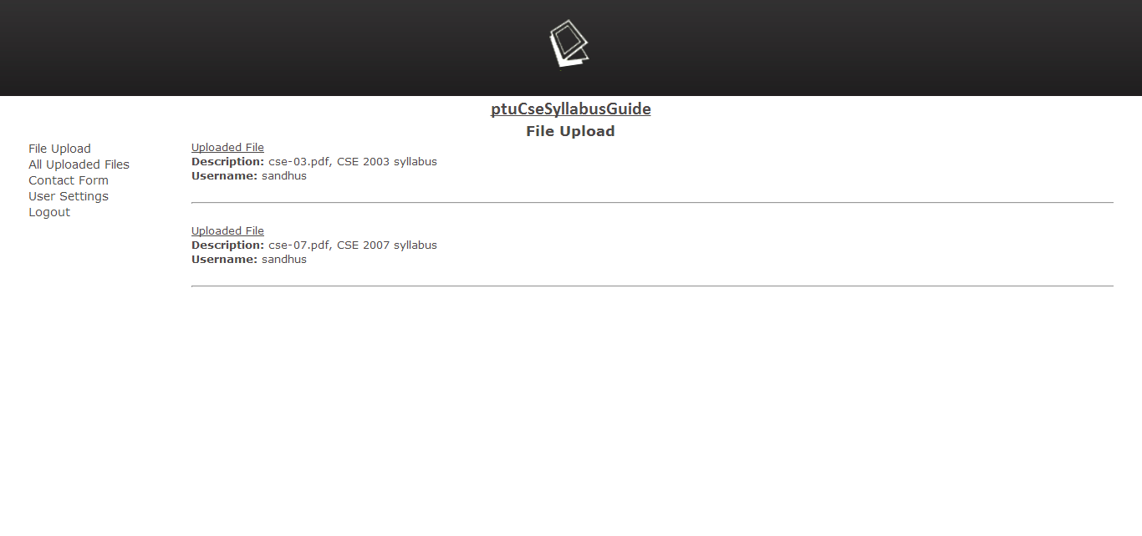

Figure 31 - List of Files uploaded by User

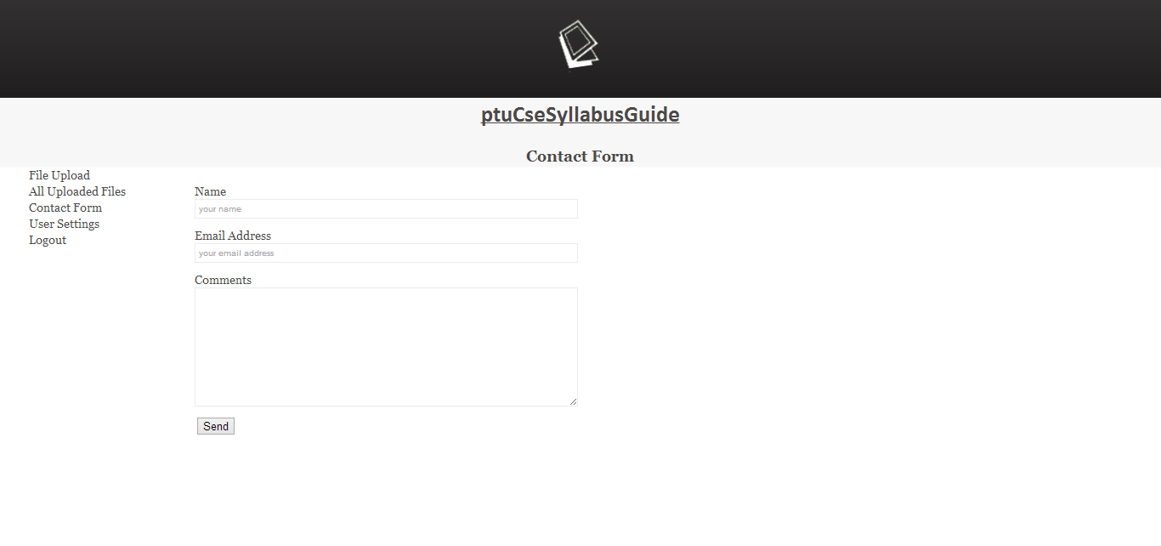

Figure 32 - Contact Form

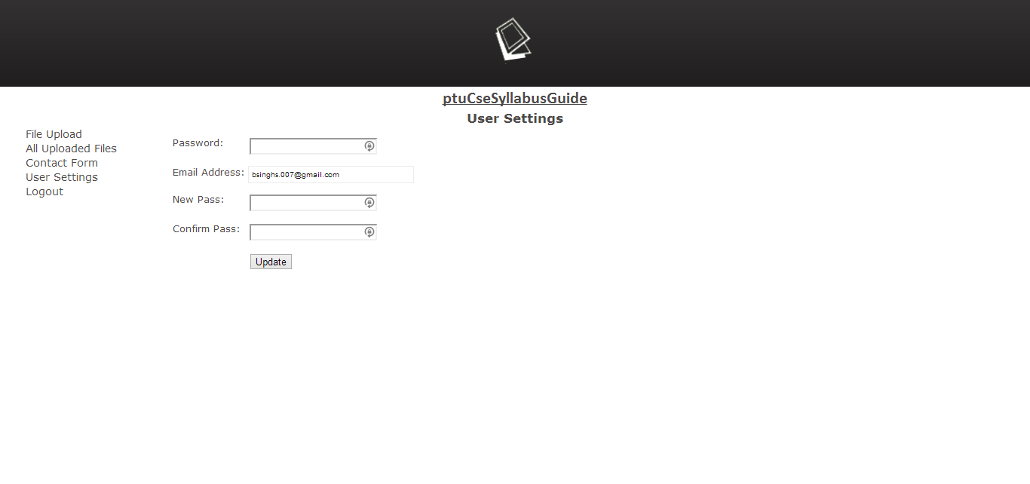

Figure 33 - Change Password

**10.Database Snapshot**

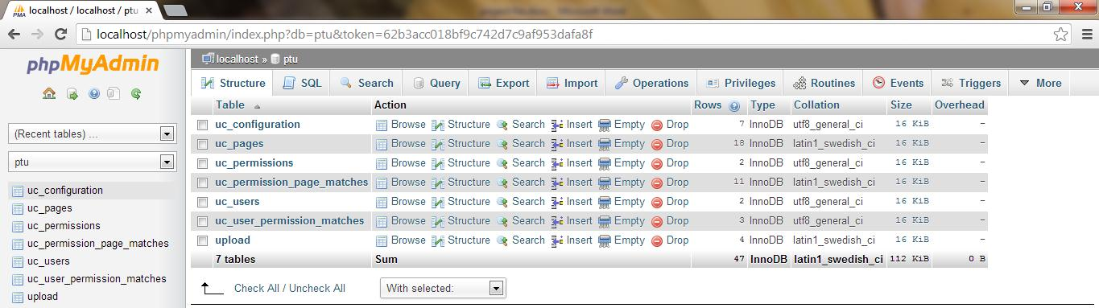

Figure 34 - Database of PTU CSE Syllabus Guide

**11.Testing**

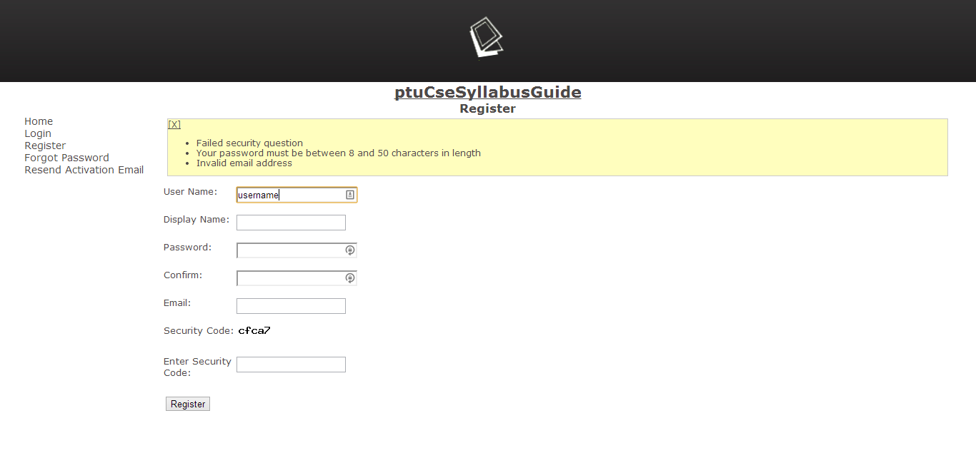

Figure 35 - User Registration form with Validation

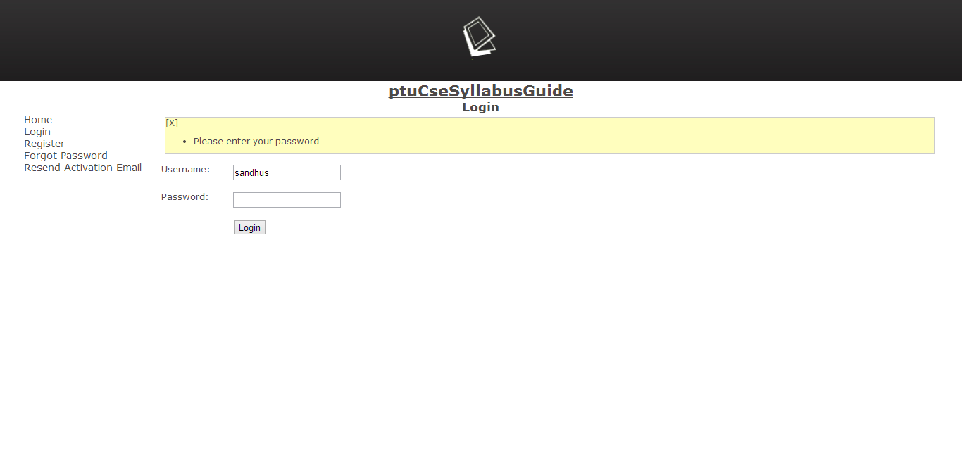

Figure 36- Login area with Validation

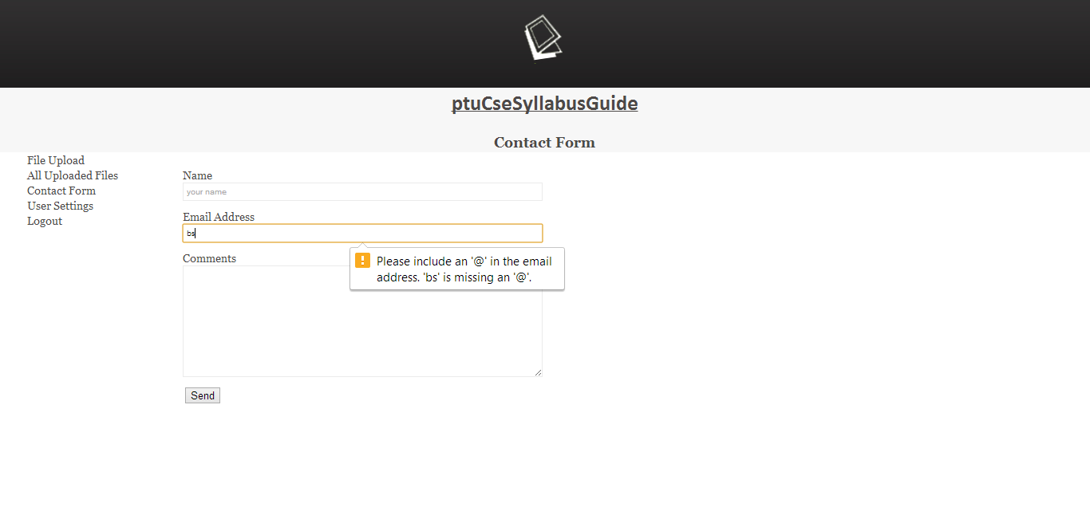

Figure 37 - Contact Form with Validation

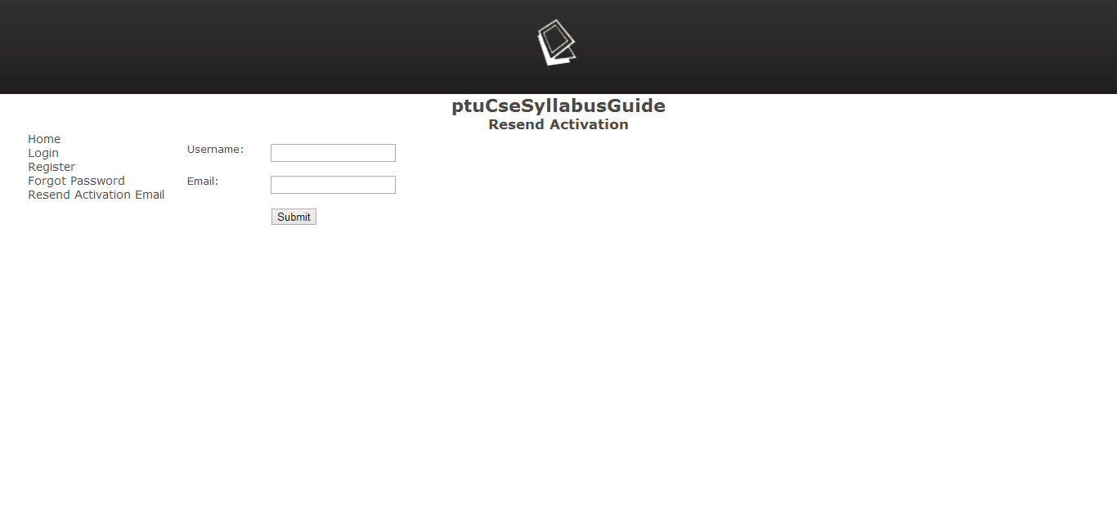

Figure 38 - Resend Activation

**12.Conclusion**

The application is made keeping in mind the requirement of the admin managing the records. The designing of application has been done in an interactive manner according to the comfortness of the user. The application can be enhanced as per the changing needs of the admin . It simplifies the task and reduce the paper work.

**13. Bibliography**

* [1] http://www.w3schools.com/php/php_intro.asp
* [2] http://www.tutorialspoint.com/php/php_introduction.htm
* [3] http://sabarsan.blogspot.in/2012/09/characteristics-of-php.html
* [4] http://www.w3schools.com/php/php_mysql_connect.asp